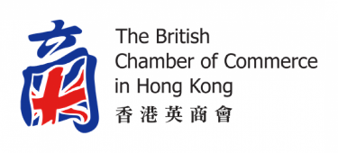**Trade & Logistics Committee Objectives**

**Aim:**

*To represent the collective interests of its members and the Chamber and to facilitate the exchange of knowledge in the field of Trade and Logistics. This encompasses Air, Land and Sea trade and logistics-related industries, primarily focused on Hong Kong, the Greater Bay Area, ASEAN countries and the United Kingdom.*

*To help our members maximize benefits from regional and local initiatives such as Free Trade Agreements including the CPTPP & RCEP, HK’s Trade Single Window and to create networks to support the building of resilient, sustainable and ethical supply chains to increase the ease and efficiency of cross-boundary trade and logistics***.**

**Objectives:**

*Our Committee:*

* to facilitate the sharing of ideas and information between Committee members by convening regular committee meetings, at least six times a year,
* to organize and host guest speakers, industry forums, site visits and social events,
* to periodically compile industry position papers on our sectors for input to the HK Government.

*Our Chamber:*

* to be the voice of the Chamber on relevant issues,
* to provide advice to the General Committee on relevant matters,
* to participate with other Chamber committees on trade and logistic-related subjects and other topics of common interest.

*Our Community:*

* to participate authoritatively in consultations conducted by the government and other agencies,
* to be actively pro-Hong Kong, and to meaningfully support initiatives taken by the Government and other bodies to promote Hong Kong as a leading global trade and logistics hub,
* to promote our industries’ transition to net-zero in support of the HKSAR government policies
* to provide logistics and trade knowledge and networks for UK companies seeking to enter the Hong Kong and China markets, particularly SMEs,
* to actively support trade and logistics activities in Hong Kong,
* to extend the committee’s reach into the wider community and to collaborate with other industry associations and organizations such as Invest HK, the HKTDC, and other British Chambers in the region,
* to focus on growing sectors such as B2C e-commerce, fine arts, healthcare and medical products.

**Members:** are expected to attend a minimum 50% of Committee Meetings during a calendar year; and to support committee and Chamber events whenever practicable.